FOOD ORDERING SYSTEM

|  |  |  |  |  |
| --- | --- | --- | --- | --- |
| S. No | Name | Registration Number | Campus | Vit Email id |
| 1 | Sneha Dutta | 20BEE0349 | Vellore | sneha.dutta2020@  vitstudent.ac.in |
| 2 | Swarnameena V | 20BIT0137 | Vellore | swarnameena.v2020@  vitstudent.ac.in |
| 3 | Chundi Sreeram Sashank | 20BEV7041 | AP | sashank.20bev7041  @vitap.ac.in |
| 4 | Rutul Ramesh Jadhav | 20BIT0037 | Vellore | rutul.jadhav2020  @vitstudent.ac.in |

REPORT

1. INTRODUCTION:
   1. OVERVIEW:

A food ordering system web app is an online platform that allows users to browse menus, place food orders, and make payments through a web-based interface. Here is a description of the key components and functionalities typically found in a food ordering system web app:

1. **User Registration and Profiles:** The web app provides a registration process where users can create their accounts. Users can then log in to access personalized features, such as order history, saved addresses, and preferences.
2. **Menu Display:** The web app displays menus from various restaurants or food vendors. Users can browse through categories, view item details, and see prices and available options (e.g., sizes, toppings, or dietary information).
3. **Search and Filtering:** Users can search for specific dishes or filter menus based on criteria like cuisine type, dietary restrictions, or price range. This helps users quickly find their desired food items from a wide selection.
4. **Cart Management:** Users can add items to their virtual cart as they browse through the menu. The web app displays a summary of the selected items, quantities, and total prices. Users can modify the cart contents, update quantities, or remove items before proceeding to checkout.
5. **Order Placement:** Once users have finalized their selections, they can proceed to the checkout process. The web app prompts users to provide delivery or pickup details, such as addresses, preferred delivery time, or special instructions.
6. **Payment Processing:** The web app integrates with secure payment gateways to facilitate online transactions. Users can choose from various payment methods, such as credit/debit cards, digital wallets, or cash on delivery (if available). The app securely handles the payment process and provides confirmation of successful transactions.
7. **Order Tracking:** If the web app supports delivery services, it may provide a tracking feature where users can monitor the progress of their orders in real-time. This can include updates on order preparation, dispatch, and estimated delivery times.
8. **Order History and Reviews:** Users can access their order history to review previous orders, reorder favorite items, or leave feedback and ratings for the food and service received. This helps users keep track of their past orders and provides valuable insights for future improvements.
9. **Administration Dashboard:** The web app also includes an administration dashboard accessible to restaurant owners or administrators. This dashboard allows them to manage menus, update item availability, view, and process orders, generate reports, and perform other administrative tasks.
   1. **PURPOSE:**

The proposed project is a Online Food ordering system is a process in which one can order various foods and beverages from some local restaurant and hotels through the use of the internet, just by sitting at home or any place. And the order is delivered to the told location. Nowadays everyone has a busy schedule whether it is in urban or rural areas. But talking specifically about the urban areas and deeply about the big cities, people out there are so busy in their life that they don’t get enough time to have their meals properly.

These days women are no less than men, in any field. So in big cities even wives are working women, therefore mostly the small families manage to have their food ordered from somewhere, as they lack time. Not only this is the case, if we talk about the children in the modern era they like only fast food or something from the outside. But they ignore eating homemade meals.

1. LITERATURE SURVEY:

**2.1 Existing Approach/Methods for this problem :**

* **Web-based Ordering System:** This approach involves developing a web application where customers can browse menus, place orders, and make payments online. The system can also include features such as order tracking, user profiles, and integration with third-party delivery services.
* **Mobile Application:** Building a mobile app provides a convenient and accessible platform for users to order food. The app can include features like location-based services, push notifications, personalized recommendations, and in-app payment options.
* **Call Center Integration:** Some customers may prefer placing orders over the phone. Integrating a call center system allows users to call a dedicated number to place their orders, while call center agents enter the order details into the system on their behalf.
* **Self-Service Kiosks:** Implementing self-service kiosks in physical locations, such as restaurants or cafes, enables customers to browse menus, customize their orders, and make payments on-site without the need for staff assistance.
* **Online Marketplace:** Creating an online marketplace where multiple restaurants or food vendors can list their menus and receive orders can offer users a wide range of options. The marketplace can handle order routing, payment processing, and delivery coordination.
* **Integration with Delivery Services:** Partnering with existing delivery service providers, such as third-party logistics companies or independent couriers, allows for seamless order delivery. Integration with their APIs or platforms enables real-time tracking and updates for customers.

**2.2 PROPOSED SOLUTION:**

Our team strongly recommends the implementation of a web-based food ordering system as it harnesses the power of technology to provide convenient services that enhance the lives of users. By leveraging technology, we can offer a seamless food ordering experience, enabling individuals to save valuable time, effort, and mental energy.

Through the web-based ordering system, users can easily browse menus, place orders, and make payments with just a few clicks. This eliminates the need for physical menu browsing, phone calls, or in-person visits, streamlining the entire ordering process, with this customer can easily order the food with variety of options very easily.

3)THEORITICAL ANALYSIS:

* 1. BLOCK DIAGRAM:

**3.2**) REQUIREMENTS OF PROJECT:

**Hardware Requirements:** Laptop/ Monitor with internet

**Software Requirements:** Operating system, Java Development Kit (JDK), Spring Boot, Integrated Development Environment (IDE)(Eclips/intellij), MySQL Database, Web Server(TOMCAT),Security(https)**.**

1. EXPERIMENTAL INVESTIGATION:

While working on a web-based food ordering system, there are severalaspects we analyzed and investigated to ensure its effectiveness and success. Here are some key areas where we have considered:

* **User Experience**: Analyze the user journey and interface of the web application to ensure it is intuitive, user-friendly, and optimized for different devices and screen sizes. Investigate user feedback, conduct usability tests, and iterate on the design to enhance the overall user experience.
* **Performance and Scalability:** Evaluate the performance of the web application, including page load times, response times, and handling concurrent user requests. Investigate potential bottlenecks and optimize the system's scalability to accommodate increasing user demand.
* **Security and Data Protection**: Analyze the security measures implemented within the web application to protect user data, including secure authentication, encryption of sensitive information, and adherence to data protection regulations. Conduct security audits and penetration testing to identify and address any vulnerabilities.
* **Order Management and Tracking:** Investigate the efficiency and accuracy of order management processes, including order placement, inventory management, and real-time order tracking. Analyze the system's ability to handle order modifications, cancellations, and refunds effectively.
* **Integration and Third-Party Services:** Analyze the integration of the food ordering system with various third-party services such as payment gateways, delivery tracking systems, and inventory management platforms. Investigate the reliability and smooth functioning of these integrations.
* **Customer Support and Feedback:** Analyze the customer support mechanisms in place, such as chatbots, FAQs, and feedback channels. Investigate customer satisfaction levels and response times to ensure efficient and satisfactory support.
* **Mobile Responsiveness:** Investigate the mobile responsiveness of the web application to ensure a seamless experience across different mobile devices. Analyze user behavior and preferences on mobile devices and make necessary optimizations.

By conducting thorough analysis and investigation in these areas, we have identified areas for improvement, optimize the performance and user experience of the web-based food ordering system, and ultimately provide a seamless and satisfactory ordering experience for customers.

5)FLOW CHART:

|  |
| --- |
| Front End Development |

|  |
| --- |
| Back End Development |

|  |
| --- |
| Integration |

|  |
| --- |
| Containerization of the Application |

.

|  |
| --- |
| Deployment to Kubernetes Cluster |

1. ADVANTAGES & DISADVANTAGES:

* While all the mentioned approaches have their own advantages and considerations, a web-based ordering system offers several benefits that make it a popular choice. Here are some reasons why a web-based ordering system can be advantageous:
* **Wide Accessibility:** A web-based ordering system can be accessed from any device with internet connectivity, including desktop computers, laptops, tablets, and smartphones. This accessibility ensures that customers can place orders conveniently from their preferred devices, making it more inclusive for a larger user base.
* **Platform Independence:** Unlike mobile applications that are typically built for specific operating systems (e.g., iOS or Android), a web-based ordering system is platform-independent. It can be accessed through standard web browsers across multiple platforms, eliminating the need for users to download and install specific applications.
* **Lower Development and Maintenance Costs:** Developing a web-based ordering system often requires fewer resources compared to building and maintaining separate mobile applications for different platforms. Web technologies, such as HTML, CSS, and JavaScript, are widely supported and require less specialized knowledge, resulting in cost savings.
* **SEO and Online Visibility:** A web-based ordering system can be optimized for search engines, enabling better visibility in online searches. This can help attract new customers by increasing organic traffic to your website and improving your online presence.
* **Seamless Integration**: Web-based ordering systems can be easily integrated with other online services and platforms, such as payment gateways, inventory management systems, customer relationship management tools, and analytics platforms. This integration allows for streamlined operations and efficient data flow between systems.
* **Costumer Support:** Web-based ordering systems often provide features such as live chat support, FAQs, and self-help resources, enhancing customer support capabilities. These features can assist customers in real-time, answering their queries and resolving issues promptly.

**DISADVANTAGES**

**Connectivity Dependencies**: Web-based ordering systems require a stable internet connection to function properly. If users or restaurants experience internet outages or disruptions, it can hinder their ability to place orders or access the system. This dependency on internet connectivity may limit the accessibility and availability of the system.

* **Technical Issues and User Support**: Web-based systems are susceptible to technical issues, such as server downtime, software bugs, or compatibility problems with different web browsers. These issues can disrupt the user experience, lead to frustration, and require prompt resolution to minimize business disruptions. Providing reliable technical support and promptly addressing user concerns becomes crucial to maintain customer satisfaction.
* **Limited Personal Interaction:** One of the drawbacks of web-based ordering systems is the absence of direct personal interaction between customers and restaurant staff. Some customers may prefer the personalized touch of speaking to a server or receiving recommendations in person. Web-based systems may lack the ability to provide detailed clarifications, dietary restrictions, or special requests that customers can communicate effectively through direct interaction.

7) APPLICATIONS

* The solution of a web-based food ordering system can be applied in various areas, including restaurants, fast food chains, food delivery services, catering businesses, food trucks, online food marketplaces, hotel room service, and institutional dining. This solution streamlines the ordering process, enhances customer experience, optimizes operations, and caters to diverse customer needs in the food industry.
* Event Management: Web-based food ordering systems can be utilized by event management companies to facilitate food ordering for large-scale events such as conferences, weddings, or festivals. Attendees can pre-order meals or make on-site selections, ensuring efficient food service and minimizing queues.
* Online Grocery Stores: In addition to prepared food, web-based ordering systems can be extended to online grocery stores. Customers can order groceries, fresh produce, and household items from a wide selection, adding convenience to their shopping experience and enabling doorstep delivery.

1. CONCLUSION:

A food ordering system is an online platform that allows users to browse menus, place food orders, and make payments through a web-based interface. It is used to streamline the food ordering process, enhance customer convenience, and optimize operations for restaurants, cafes, delivery services, and more. The advantages of a food ordering system include time savings, improved accessibility, personalized ordering, and efficient order management. However, it is dependent on internet connectivity, may lack personal interaction, and can encounter technical issues.

The front-end of a food ordering system involves developing a user-friendly interface for customers to browse menus, customize orders, and make payments. The back-end encompasses the server-side development that handles order processing, inventory management, and database operations. Integration involves connecting the system with payment gateways, third-party services, and delivery tracking APIs. Containerization involves packaging the application components into containers (e.g., Docker) for portability and scalability. Deployment to Kubernetes clusters allows for efficient management and scaling of the application across multiple containers.

By providing a comprehensive and user-friendly food ordering experience, businesses can attract and retain customers while improving operational efficiency. However, it's essential to consider the challenges, such as technical dependencies and the need for reliable connectivity, to ensure a successful implementation of the food ordering system.

1. FUTURE SCOPE:

* Artificial Intelligence and Machine Learning for personalized recommendations and predictive order fulfillment.
* Voice-enabled ordering through integration with virtual assistants.
* Augmented Reality (AR) menu visualization for immersive and interactive menu experiences.
* Integration with IoT devices for seamless connectivity and automated ordering.
* Blockchain technology for enhanced food traceability and transparency.
* Social media integration to drive customer engagement and user-generated content.
* Virtual Reality (VR) dining experiences for immersive and unique dining options.
* Emphasis on sustainability and green initiatives for eco-friendly practices.

These advancements demonstrate the potential for web-based food ordering systems to incorporate emerging technologies, enhance user experiences, and address evolving customer demands in the future.

1. BIBILOGRAPHY:
   1. Title: "Spring Boot in Action"

Author: Craig Walls

Publisher: Manning Publications

Year: 2020

* 1. Title: "Spring Boot Cookbook"

Author: Alex Antonov

Publisher: Packt Publishing

Year: 2019

* 1. Title: "Pro Spring Boot 2: An Authoritative Guide to Building Microservices, Web, and Enterprise Applications"

Authors: Felipe Gutierrez, Mohamed Sanaulla

Publisher: Apress

Year: 2019

* 1. Title: "Spring Boot 2 Recipes: A Problem-Solution Approach"

Authors: Marten Deinum, Josh Long, Daniel Rubio, Thierry

Publisher: Apress

Year: 2018

1. APPENDIX:

* Sign up page React form :

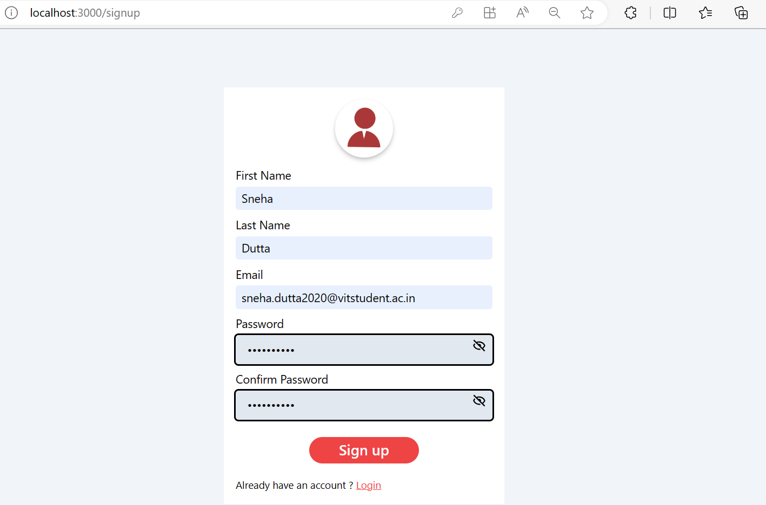

* Mysql database for Signed in Users :

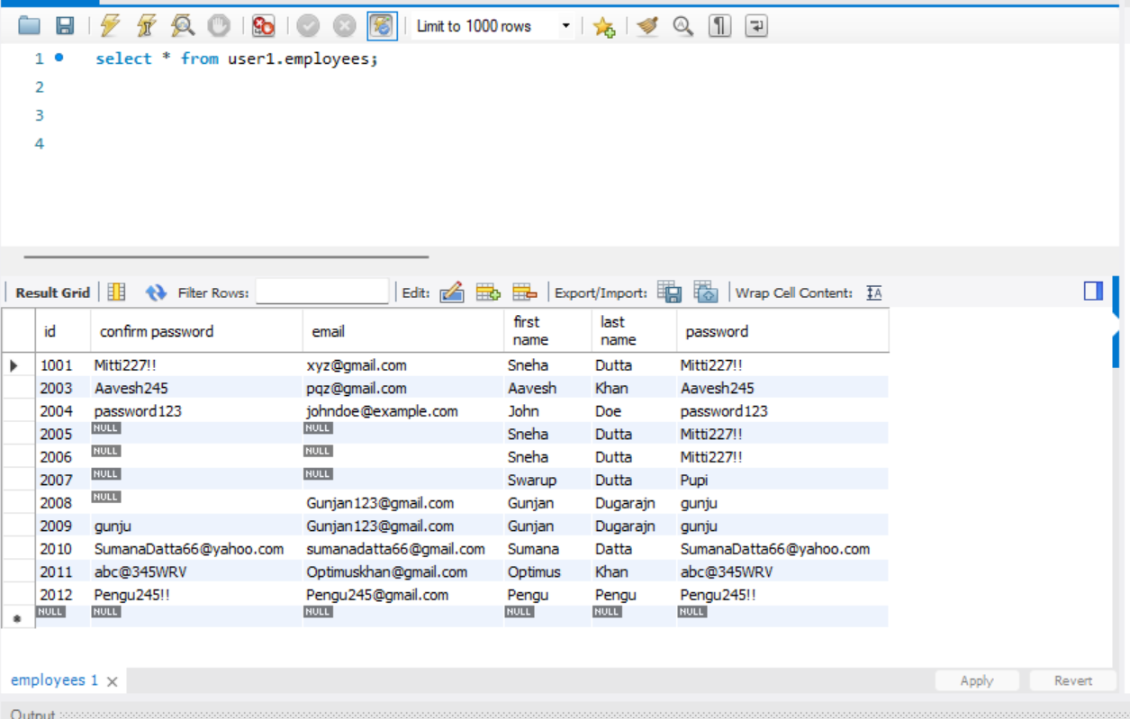

* Log in page

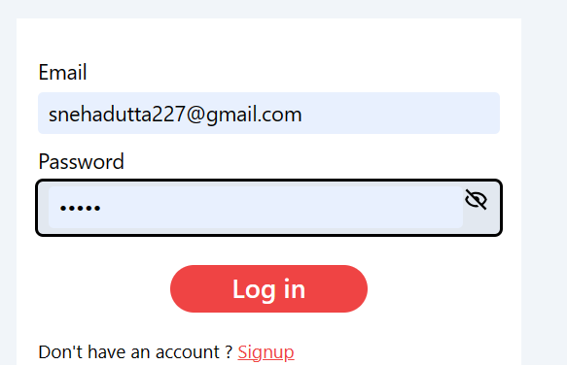

* New product Page( only available to Admins)

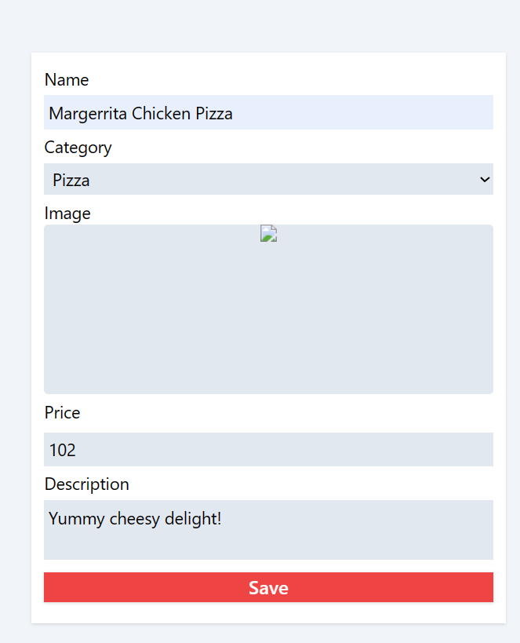

* New products page (Mysql database)

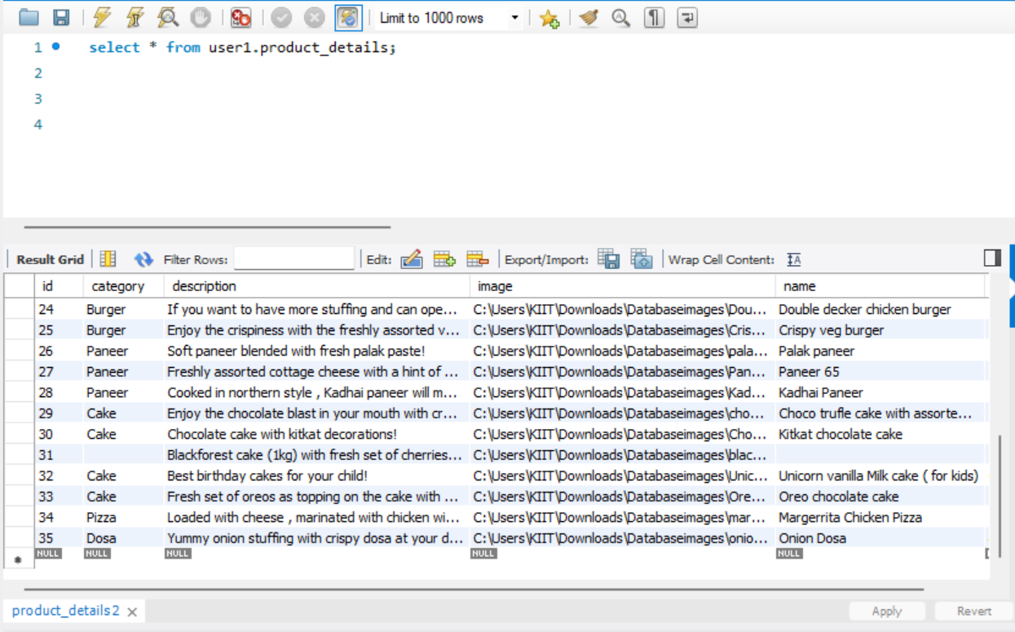

* Home Page (Front end Part-1)

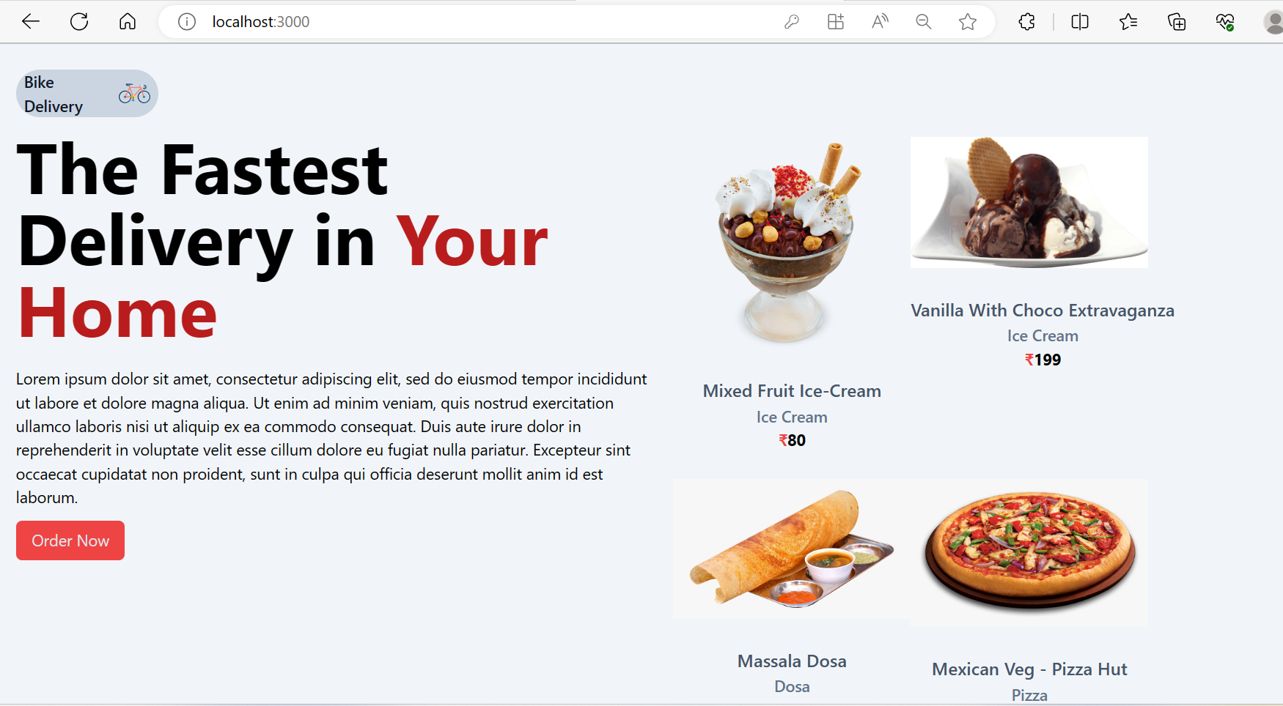

Home Page (Front end Part-2)

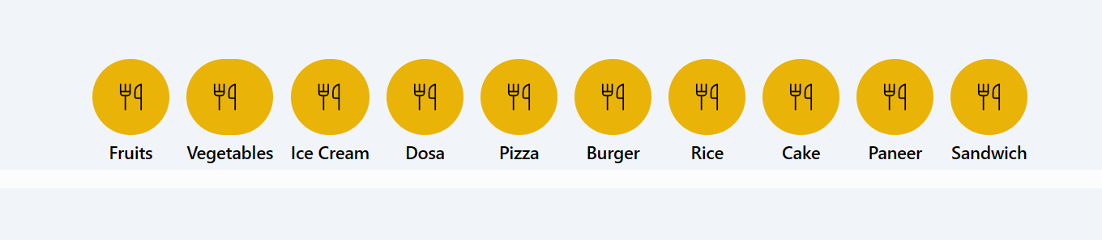

* On clicking the icon category the list of items of that particular category are displayed :

Supposed if we select cake, all the various types of cakes are displayed :

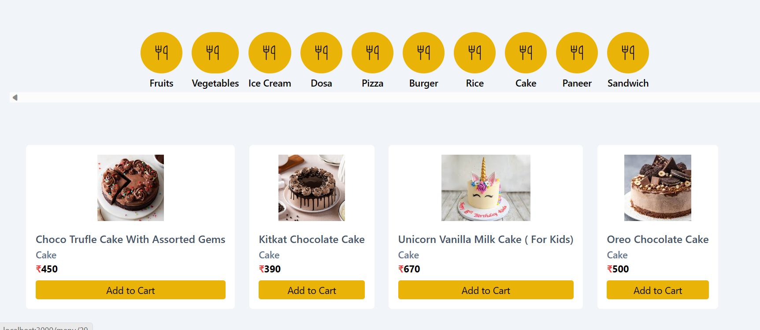

* Add To cart

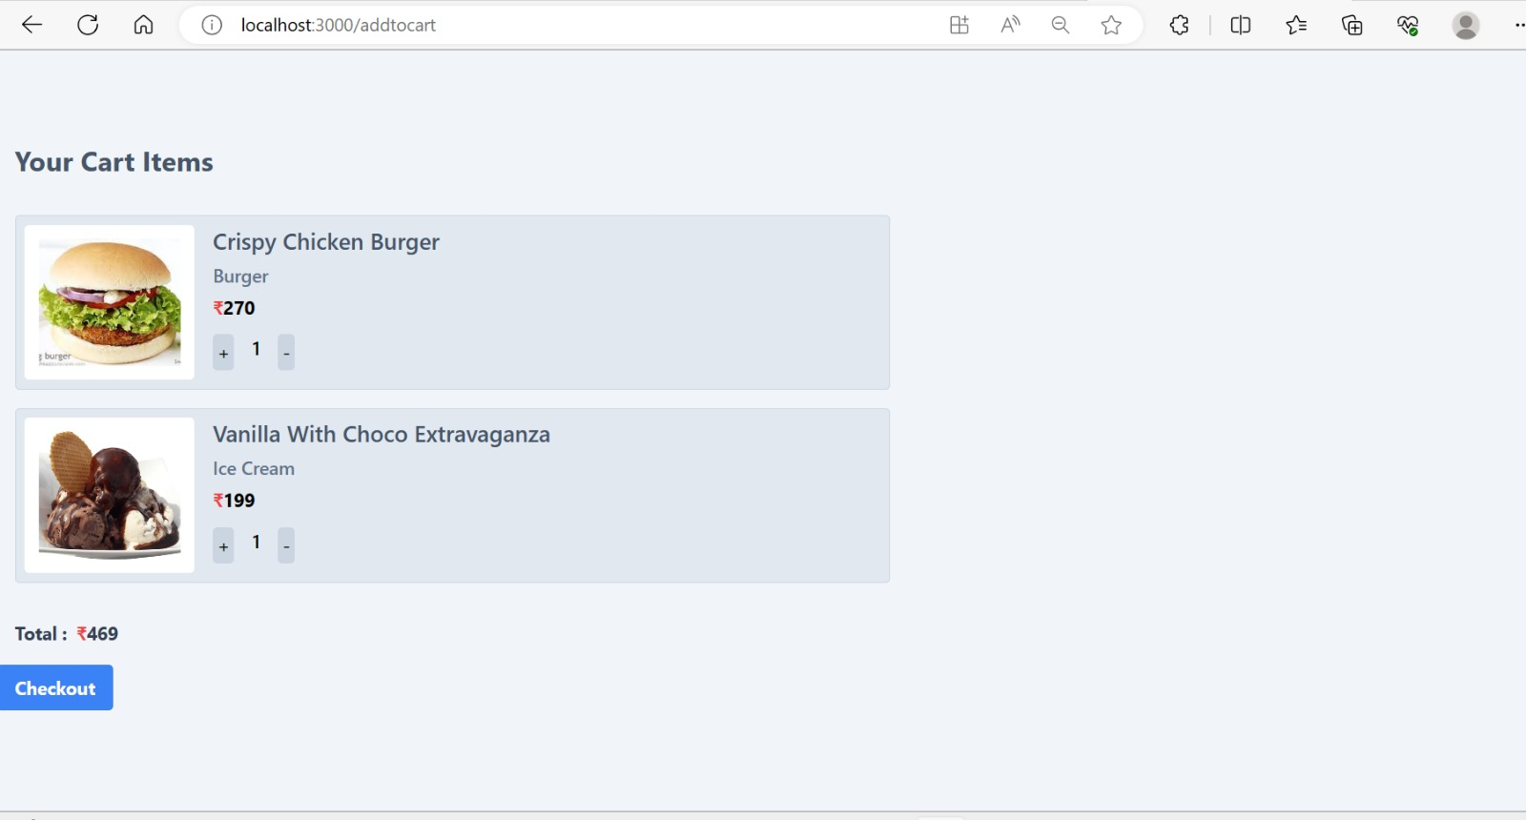

* Payment

